REPORT LAB 4 CA – ITITIU19228

Excercise 1.1

* 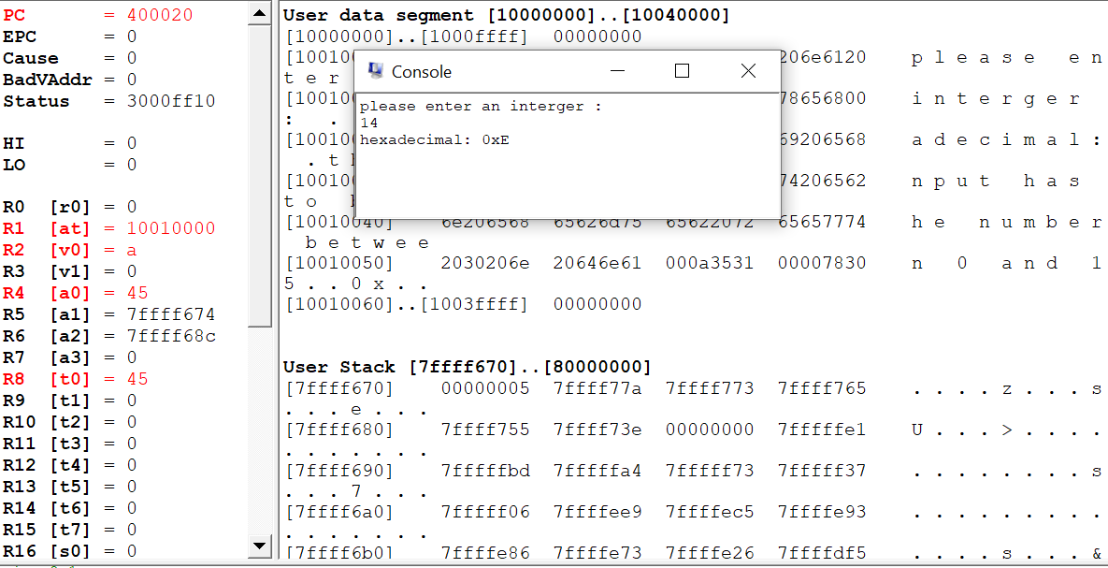

Exercise 1.2

* 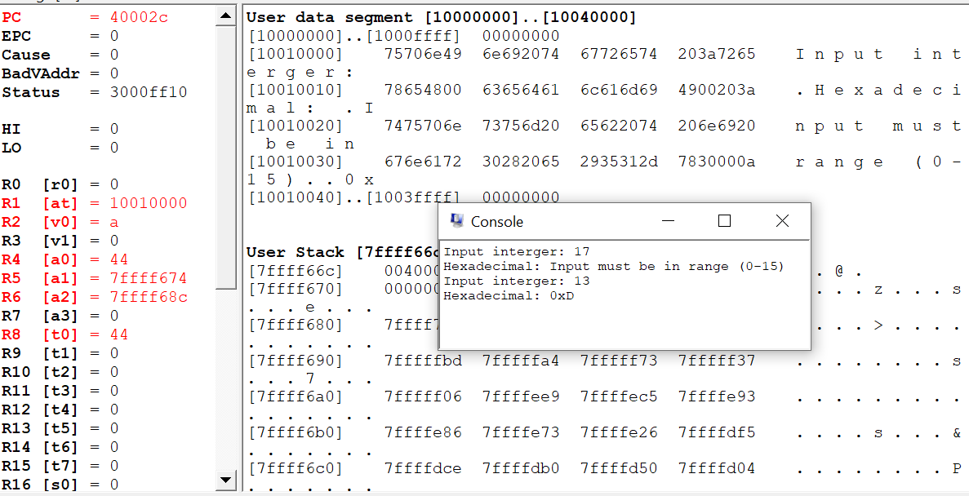

Exercise 1.3

* 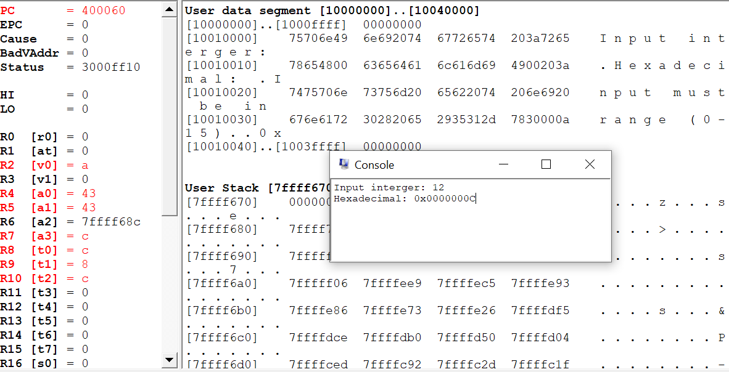

Exercise 2.1

* 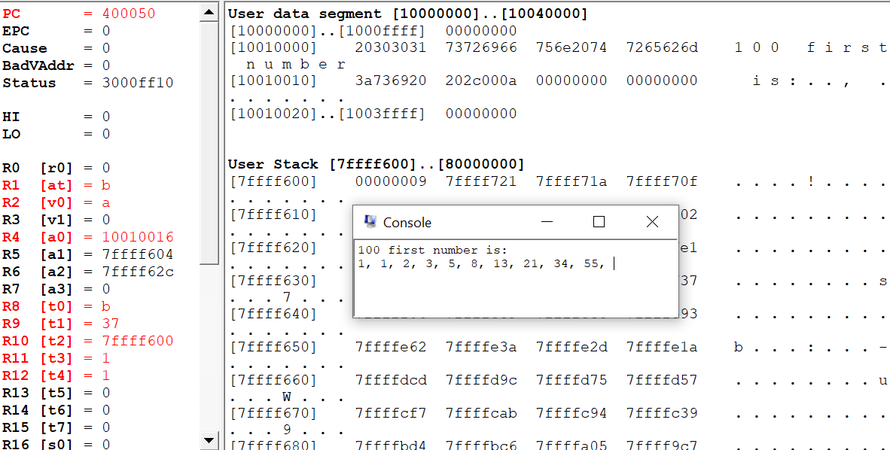

Exercise 2.2

* 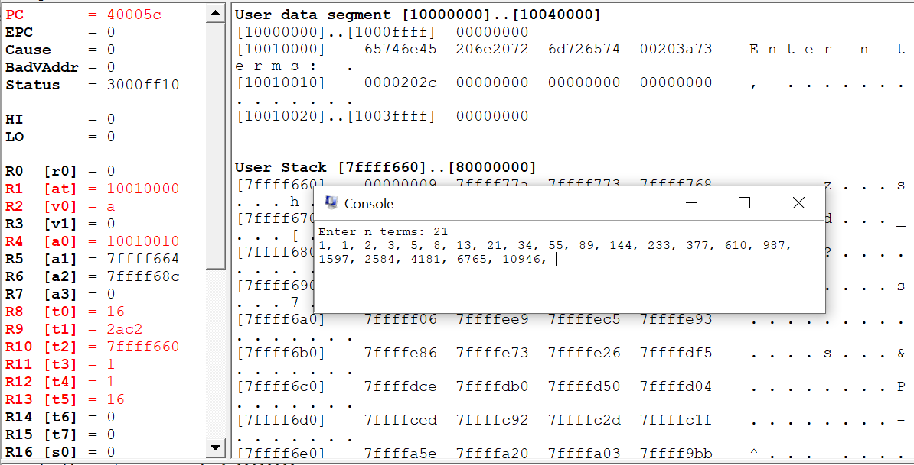

Exercise 2.3

* 